Friday 10th March 2023
Morning everyone,
I hope that you are all keeping warm this morning. It is still snowing here in Knaresborough! Hope you enjoy the snow today!
As school is closed, we will be learning online today. Here are some links to lessons to complete.
English
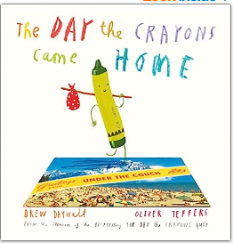
Watch - (289) The Day the Crayons Came Home - Animated Read Aloud - YouTube
Choose one of the following activities to do:
- Write a new postcard for a crayon you have created, e.g., rainbow crayon.
- Create a story about 'Estaban the Magnificent' (also known as Pea Green crayon). What adventures does he have when he tries to run away to see the world?
- Look at the use of upper and lower case letters in the story. Can you correct any 'mistakes'? Why has the author used upper / lower case letters in this way?
- Write a scary story about something that has happened to 'Glow in the dark' crayon.
- Create a new story about Duncan's crayons.
Maths
Warm up
- Practise your times tables on TTRockstars.
- Practise other recall facts on Hit the Button
Main Maths
We’ve been learning about multiplying and dividing by 10/100/1,000 (including decimals)
- Watch the Oak Academy Video
- Visit Topmarks Moving Digits and notice how the digits move. Left or Right? How many places?
- Make a poster about what happens to the digits when you..
- multiply by 10
- divide by 10
Extension – do the same for 100 and 1,000
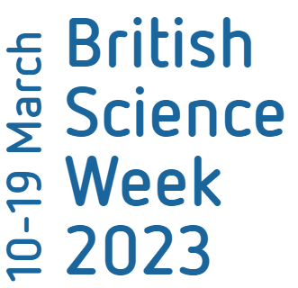
Science
Next week is British Science Week which is a ten-day celebration of science, technology, engineering and maths.
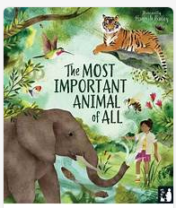

The theme is 'Connections', and St. Peter’s will be using the book 'The Most Important Animal of All'.
Herons Class has been tasked with the wolf!

Could you start to research the wolf? You could create a class poster, a list, a PowerPoint, etc. It is up to you!

All learning and photos will be shared when back in school.
Take care and have a lovely weekend.

Mrs Robbins x

